Industrial Internship Report on

”Quality Prediction of a Mining Process” Prepared by

Aayushi Bhavsar

Executive Summary

This report provides details of the Industrial Internship provided by upskill Campus and The IoT Academy in collaboration with Industrial Partner UniConverge Technologies Pvt Ltd (UCT).

This internship was focused on a project/problem statement provided by UCT. We had to finish the project including the report in 6 weeks’ time.

My project was about Detecting crops from weed which will create a system that only sprays pesticides on weed and not on the crop Which will reduce the mixing problem with crops and reduce the waste of pesticides.

This internship gave me a very good opportunity to get exposure to Industrial problems and design/implement solution for that. It was an overall great experience to have this internship.

TABLE OF CONTENTS

1 Preface ....................................................................................................................................................3

2 Introduction ............................................................................................................................................4

2.1 About UniConverge Technologies Pvt Ltd .........................................................................................4

2.2 About upskill Campus ........................................................................................................................8

2.3 Objective..........................................................................................................................................10

2.4 Reference.........................................................................................................................................10

2.5 Glossary............................................................................................................................................10

3 Problem Statement...............................................................................................................................11

4 Existing and Proposed solution.............................................................................................................12

5 Proposed Design/ Model ......................................................................................................................13

5.1 High Level Diagram (if applicable) ...................................................................................................13

5.2 Low Level Diagram (if applicable) ....................................................................................................14

5.3 Interfaces (if applicable) ..................................................................................................................14

6 Performance Test..................................................................................................................................15

6.1 Test Plan/ Test Cases .......................................................................................................................15

6.2 Test Procedure.................................................................................................................................15

6.3 Performance Outcome ....................................................................................................................15

7 My learnings..........................................................................................................................................16

8 Future work scope ................................................................................................................................17

1. **Preface :**

I started the project “Quality Prediction in a Mining Process” by first analyzing the dataset. The dataset access was the tricky part since it was given in YOLO format. After that I trained my ML model to differentiate between crops and weed. I used a CNN model to extract the relevant features from the image dataset. Finally, the trained ML model was able to classify the test images accurately.

This Internship helped in my personal growth and helped me identify what areas I am good at and what areas do I need to improve upon. Internship are a critical step in one’s career.

My project was about Detecting crops from weed which will create a system that only sprays pesticides on weed and not on the crop Which will reduce the mixing problem with crops and reduce the waste of pesticides.

This was a golden opportunity given to me by Uni-Convergence-Technology ltd. (UCT/USC). I was able to fully develop my skills and could complete the tasks successfully.

The Program was planned very meticulously. The course allowed me to improve upon my skills. The program organizers gave us clear schedule which helped keep my reports on tracks.

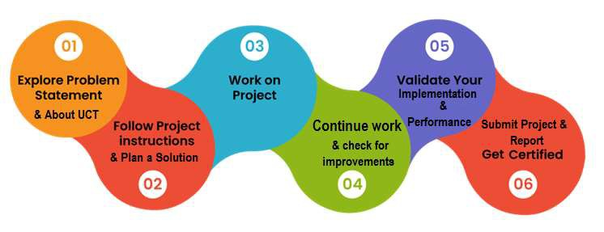

This internship contributed to my learning significantly. It helped me grow in a professional as well as in a personal way. I became more proficient in my field of study i.e., Data Science and Machine Learning.

I thank all my co-mentors and the internship organizer for giving me this opportunity to work on my skills and help me in my career growth.

I thereby give small advice to all my juniors and peers that no matter how tough it gets to manage your time to complete all the weekly assignments, keep working hard and do not give up. Since the result will be very fruitful.

**2 Introduction :**

2.1 About UniConverge Technologies Pvt Ltd

A company established in 2013 and working in Digital Transformation domain and providing Industrial solutions with prime focus on sustainability and RoI.

For developing its products and solutions it is leveraging various Cutting Edge Technologies e.g., Internet of Things (IoT), Cyber Security, Cloud computing (AWS, Azure), Machine Learning, Communication Technologies (4G/5G/Lora WAN), Java Full Stack, Python, Front end etc.

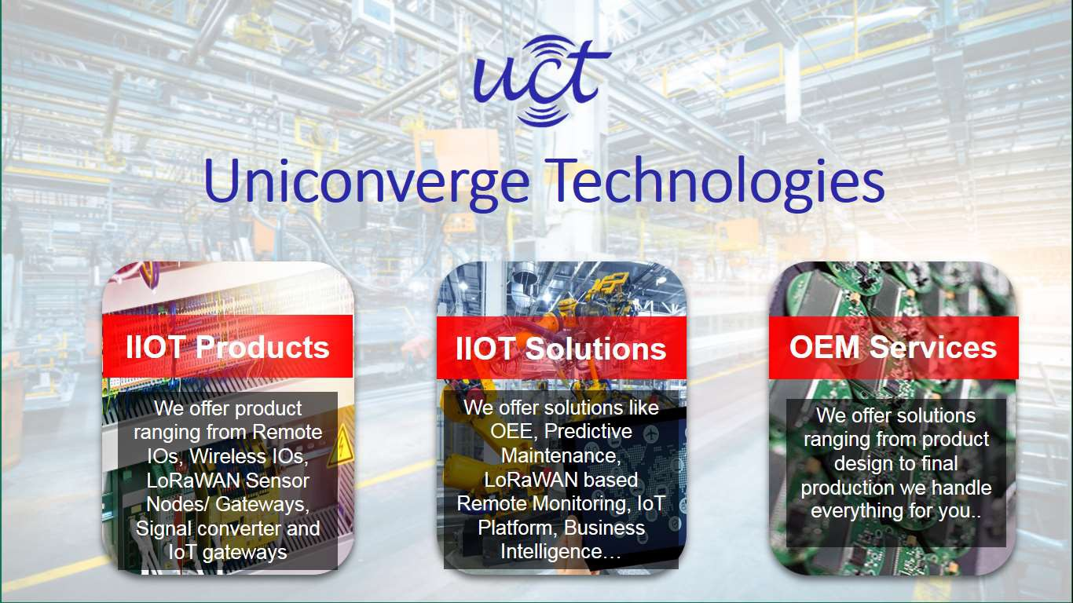

i. UCT IoT Platform ( )

UCT Insight is an IOT platform designed for quick deployment of IOT applications on the same time providing valuable “insight” for your process/business. It has been built in Java for backend and ReactJS for Front end. It has support for MySQL and various NoSQL Databases.

• It enables device connectivity via industry standard IoT protocols - MQTT, CoAP, HTTP, Modbus

TCP, OPC UA

• It supports both cloud and on-premises deployments.

It has features to

• Build Your own dashboard

• Analytics and Reporting

• Alert and Notification

• Integration with third party application (Power BI, SAP, ERP)

• Rule Engine

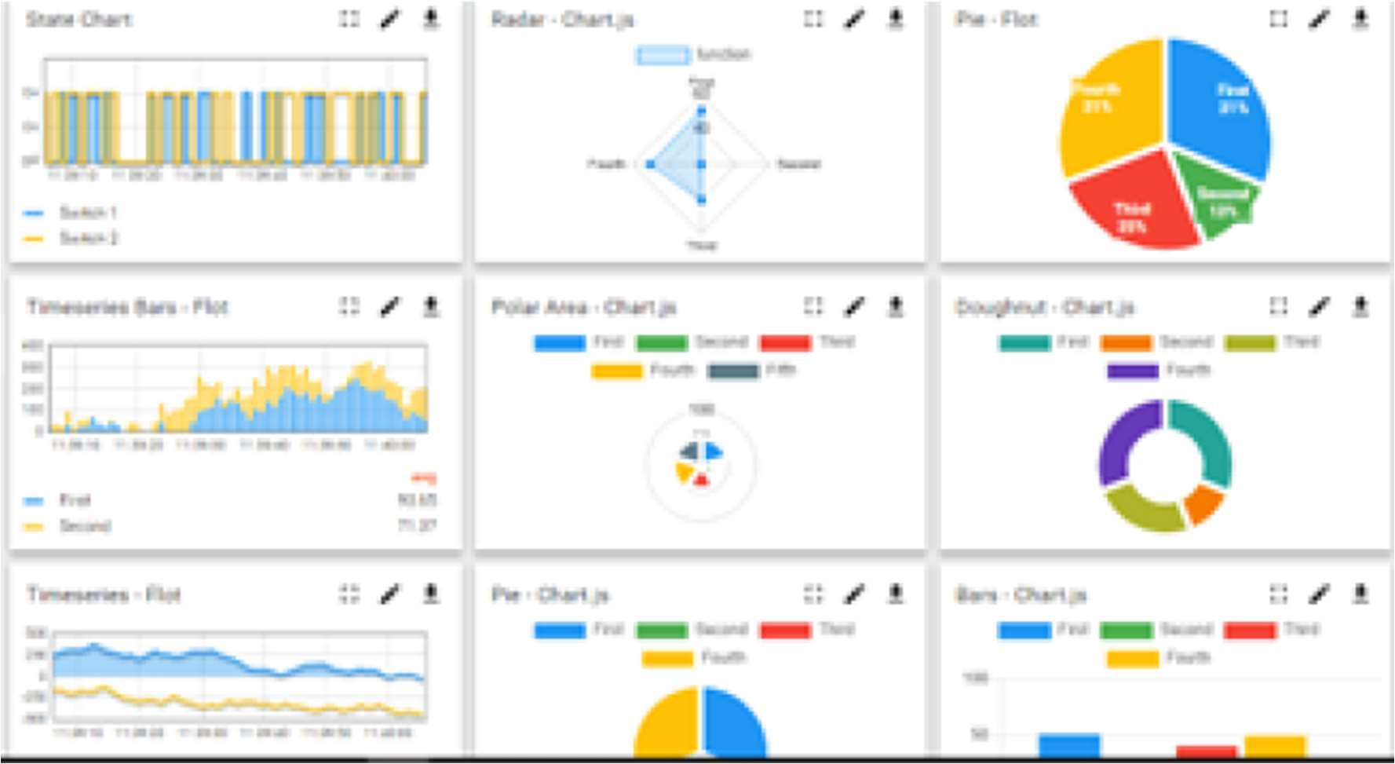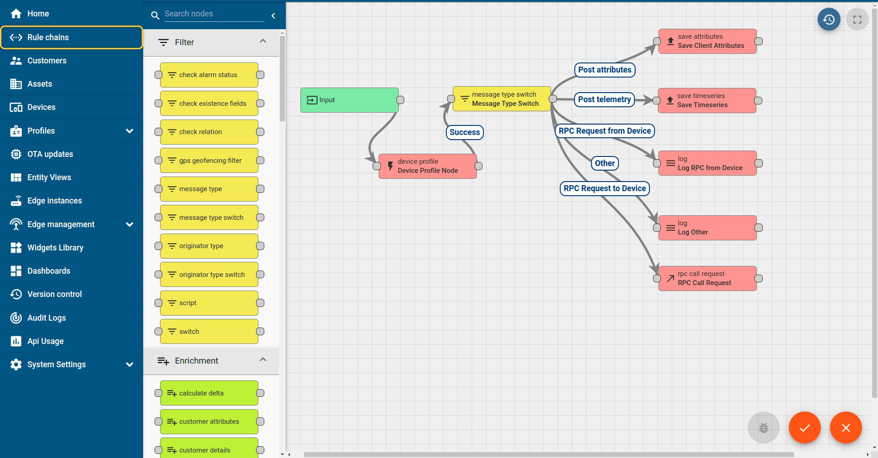

ii. Smart Factory Platform ( )

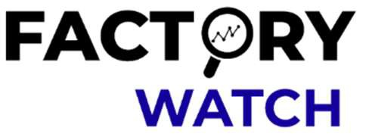

Factory watch is a platform for smart factory needs. It provides Users/ Factory

• with a scalable solution for their Production and asset monitoring

• OEE and predictive maintenance solution scaling up to digital twin for your assets.

• to unleased the true potential of the data that their machines are generating and helps to identify the KPIs and also improve them.

• A modular architecture that allows users to choose the service that they what to start and then can scale to more complex solutions as per their demands.

Its unique SaaS model helps users to save time, cost and money.

Industrial Internship Report Page 7

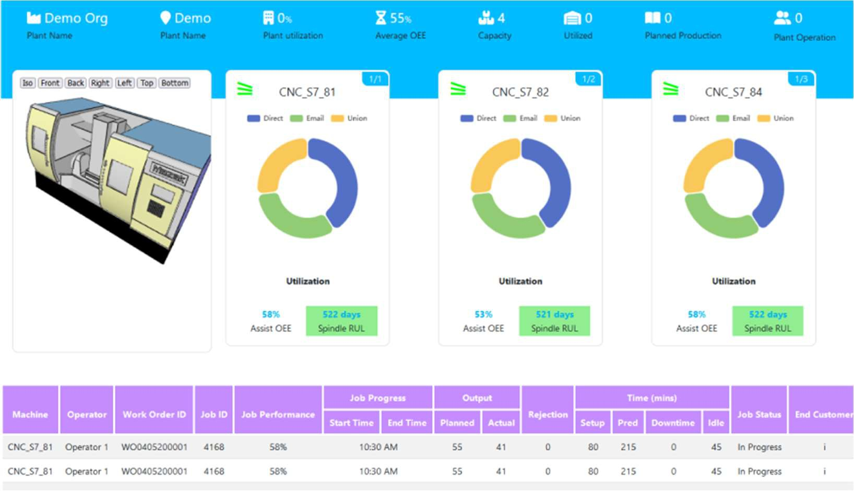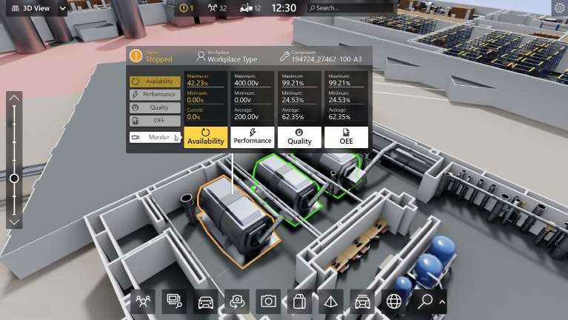

iii. based Solution

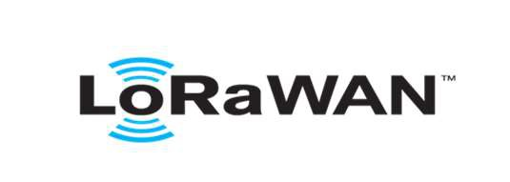

UCT is one of the early adopters of Lora WAN technology and providing solution in Agritech, Smart cities, Industrial Monitoring, Smart Street Light, Smart Water/ Gas/ Electricity metering solutions etc.

iv. Predictive Maintenance

UCT is providing Industrial Machine health monitoring and Predictive maintenance solution leveraging embedded system, Industrial IoT and Machine Learning Technologies by finding remaining useful life time of various Machines used in production process.

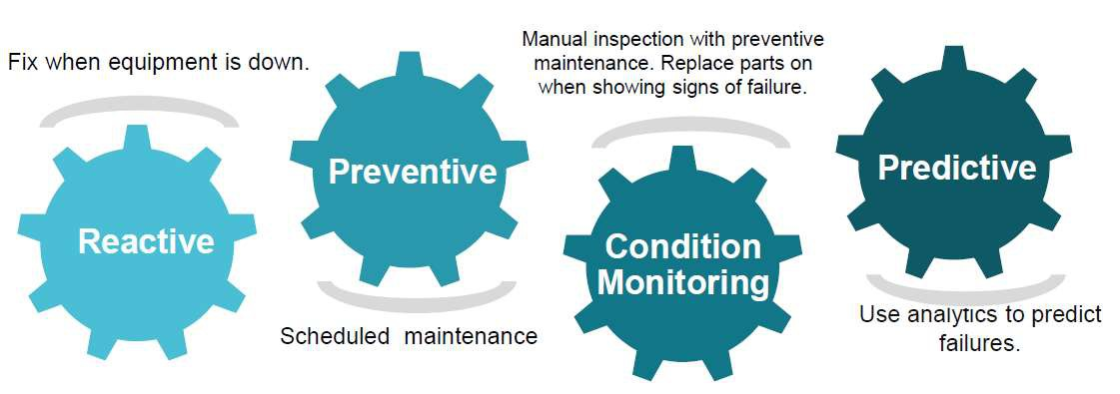

2.2 About upskill Campus (USC)

Upskill Campus along with The IoT Academy and in association with UniConverge technologies has facilitated the smooth execution of the complete internship process.

USC is a career development platform that delivers personalized executive coaching in a more affordable, scalable and measurable way.

Seeing need of upskilling in self-paced manner along-with additional support services e.g. Internship, projects, interaction with Industry experts, Career



growth Services

Upskill Campus aiming to upskill 1 million learners in next 5 year

https:/[/www.upskillcampus.com/](http://www.upskillcampus.com/)

Interview Preparation and skill building

Career growth/upskilling

upskilling Courses Skill Assessment Profile building

Alumni

Connections

Mentorship

Discussion/QA

Professional networking

forum

Project collaboration

Collaboration platform

Discussion forum

Tech updates

Job portal

Internship portal

Freelancing projects

Job/internship platform

2.3 The IoT Academy

The IoT academy is EdTech Division of UCT that is running long executive certification programs in collaboration with EICT Academy, IITK, IITR and IITG in multiple domains.

2.4 Objectives of this Internship program

The objective for this internship program was to

☛get practical experience of working in the industry.

☛to solve real world problems.

☛to have improved job prospects.

☛to have Improved understanding of our field and its applications.

☛to have Personal growth like better communication and problem solving.

2.5 Reference

[1] https://www.kaggle.com/code/dgcoder/timeseries-big-data-project

[2] https://www.kaggle.com/code/jmas19/mining-process-project

2.6 Glossary

Terms Acronym

Convolutional Neural Network CNN You Only Look Once YOLO Machine Learning ML

1. **Problem Statement :**

The mining industry faces numerous challenges related to quality control. One of the primary issues is the inconsistent quality of the extracted materials, which can lead to inefficient processing and increased operational costs. Variability in ore quality can also result in equipment wear and tear, leading to unplanned maintenance and downtime. Additionally, poor quality control can pose significant safety risks to workers and the environment. Traditional methods of quality prediction often fall short due to their inability to handle large volumes of data and the complex relationships between different variables in the mining process.

**4 Existing and Proposed solution :**

Earlier solutions provided previously was basically trying to solve the same problem but the accuracy obtained in solving the problem was low and sometimes the model could not classify the crop and weed correctly.

I have proposed in severely training my model in such a way that the CNN model will be able to provide correct classification when tested on test images.

4.1 Code submission (Github link)

[GITHUB CODE LINK](https://github.com/VasuPatel5541/upskillcampus)

4.2 Report submission (Github link) :

[GITHUB REPORT WEEK 6](https://github.com/VasuPatel5541/upskillcampus)

**5 Proposed Design/ Model:**

Design Flow of the Solution

The starting stage of the model is preprocessing the images for training. Then the model is prepared for training to detect the weeds. The model is then trained using CNN. Then the predictions are made using the deep learning model.

5.1 High Level Diagram

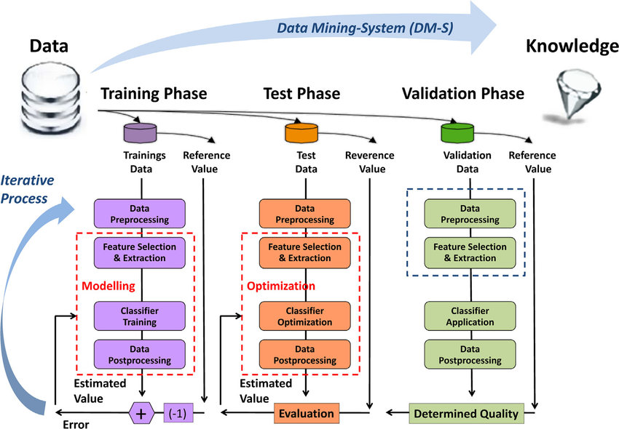

Figure 1: HIGH LEVEL DIAGRAM OF THE SYSTEM

5.2 Low Level Diagram

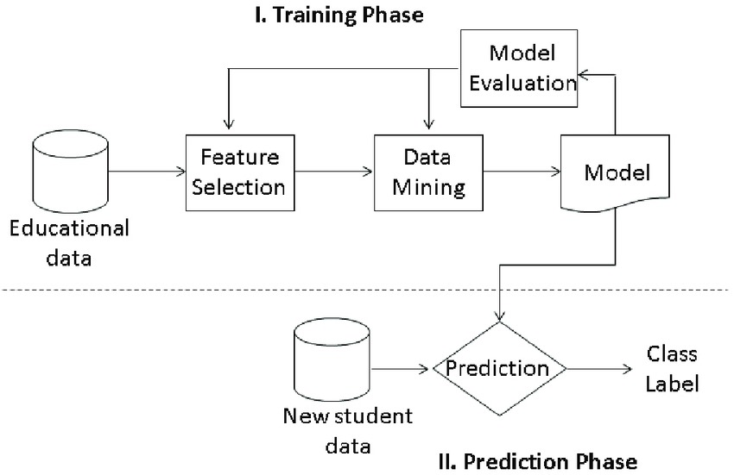

5.3 Interfaces

Block Diagrams

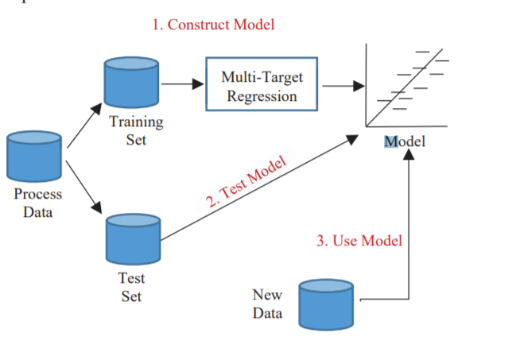

**6 Performance Test:**

* Performance testing plays a crucial role in demonstrating the real-world applicability of this project to the mining industry, rather than it being merely an academic exercise.
* The primary constraints in my project were the accuracy of the predictions and the speed at which the output is generated.
* In my design, I trained the model multiple times using various machine learning algorithms, such as decision trees and random forests, to identify the algorithm best suited to achieve the highest accuracy.
* The test results showed significant improvements compared to previous work in the field. Identifying and addressing constraints is essential for training a model that is viable for real-life applications.

6.1 Test Plan/ Test Cases

My main testing plan involved in testing the already trained model with various images so that model could become equipped with how to classify the crop and weed.

6.2 Test Procedure

First step was to train the model with epoch using the CNN. Then the images not used in training was used to test the accuracy of the model in the classification task.

6.3 Performance Outcome:

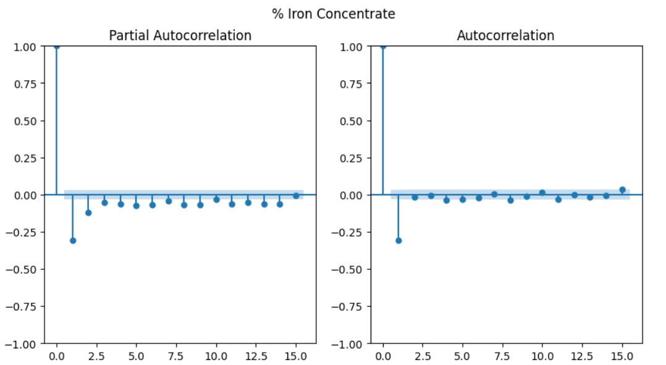

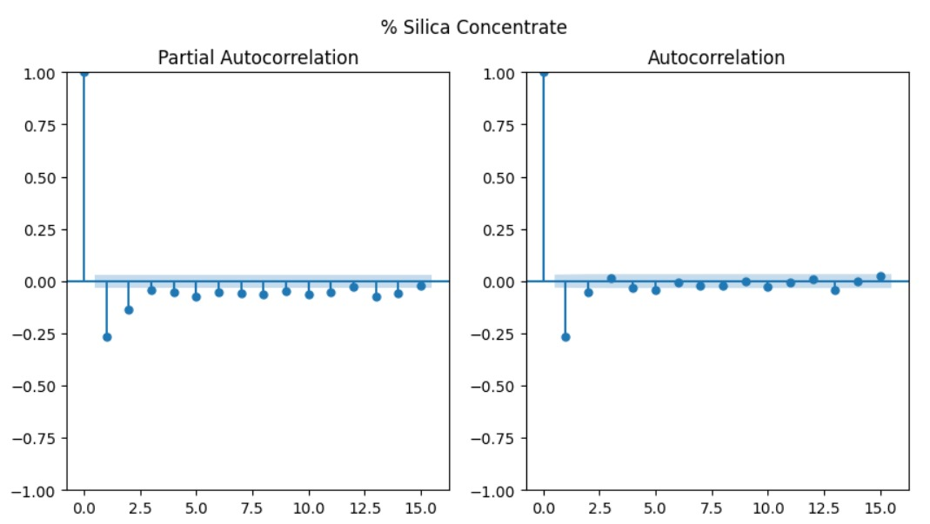

7 My learnings:

I learned the importance of machine learning libraries and how they help us solve real-life problems. The problem statement on the quality prediction in a mining process is of real practical importance and can be used by mining companies all around the world. The knowledge obtained through this internship will help me achieve successful growth and development in both my professional and personal life.

8 Future work scope:

I wanted to add my code for quality prediction in a mining process into a Flask module, so that mining companies all around the world can make use of this project to identify the quality of ore being processed. The model integration with the webpage will give this project an edge and will make it easy for mining professionals or any layman to use.